Biometrics4ALL Account Registration
Please setup an account and register with www.applicantservices.com/sba
- Go to www.applicantservices.com/sba
- Select “Login” in the top right hand corner of the screen.
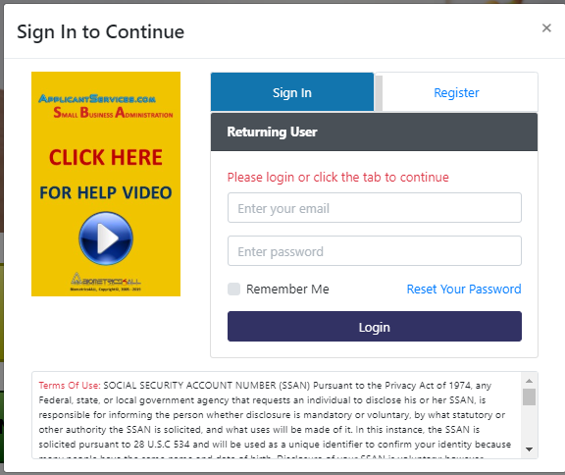
- Click on the “Register” tab in the popup window.
- Enter your email and all of the information requested on the screen.
- You will receive an Activation Email from Support@ApplicantServices.com. If you do not receive an email, please check your spam box.
- Click on the link (or copy the link) provided in the Activation Email.
- On the Activation Link, enter your cell phone number to receive text messages.
- Wait for a text from Support@ApplicantServices.com to your cell phone containing a single use 6 number code.
- Enter this code to complete the registration process. Once the code is entered, it will say that the activation was successful and then redirect you back to the Sign In screen. Select the “X” to close the screen. To go back to the main screen select the logo in the upper left hand side of the screen “ApplicantServices.com”
- On the main screen Select the “None-Disaster – SBA Form 912” green button.
- Sign In, each time you login it will send you a single use code.
- Step I: Transaction: Reason Fingerprinted: SBA, select “Next”
- Step 2: Personal: Enter any missing information, verifying all fields. Once everything is entered select “Next”.
- Step 3: Demographics: Enter in the required information then select “Next”.
- Step 4: Locations: Shows the nearest locations to your address on file. If there are no electronic fingerprinting locations within 25 miles you have two choices (1) go to the closest Livescan location shown. (2) Select the Mail-in Card Scan Processing Center option. See our Mail-In Fingerprint notes for detailed instructions.
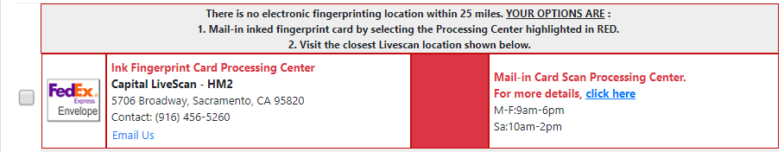
- Once you have found a location write down the name and address of the location. Select the location, select “Next”. Note: Select the “Directions” button and it will give you turn-by-turn directions in a new tab.
- Step 5: If you choose a location and select “Next” it will come up and show you dates and times available for making an appointment, select a date and time that works for you. Select “Next”.
- Step 6: Payment: No payment is due at this time.
- Step 7: Confirmation: If you select Mail-In Card in Step 4 it will skip to Step 7. Verify the Information and select “Submit”. Note: We recommend that you call the service center in advance to confirm everything.
- Step 8: Print Form: Verify the information and print the form. Select “Next”.
- Step 9: Receipt: Verify the information and print the form. Select “Next”.
- An email will be sent to you with additional instructions to complete the fingerprint portion of the process.

